Software engineering for AI

techniques

Lab assignment

NAME: D.PravinRaj

REG NO: 192110177

DAY: 4

1. Draw a Activity diagram for Online Railway Reservation System using CASE tools.

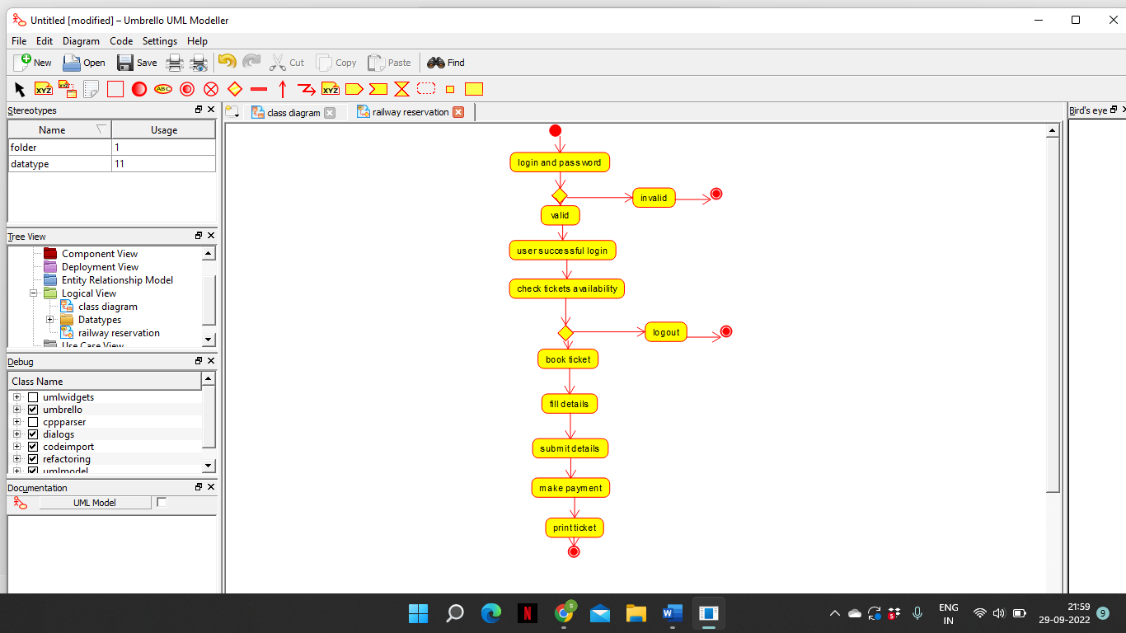

1. Draw a Activity diagram for Hospital Management System using CASE tools.

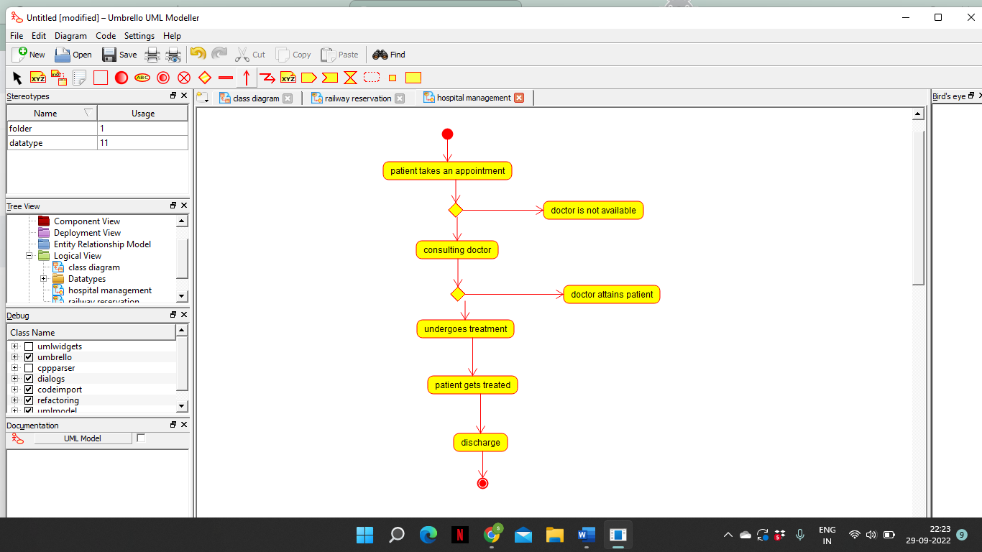

1. Using Raptor- Draw the flowchart to check whether the given number is a palindrome or not.

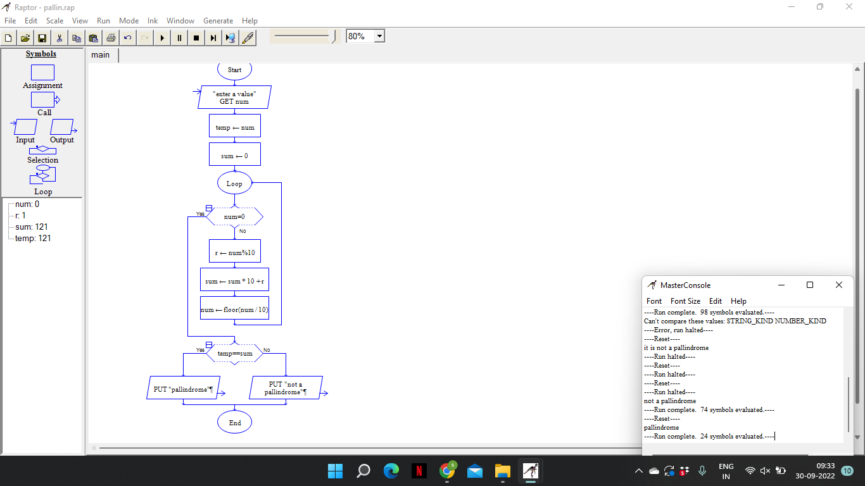

1. Using Raptor- Draw and validate the flowchart to calculate Fibonacci series.

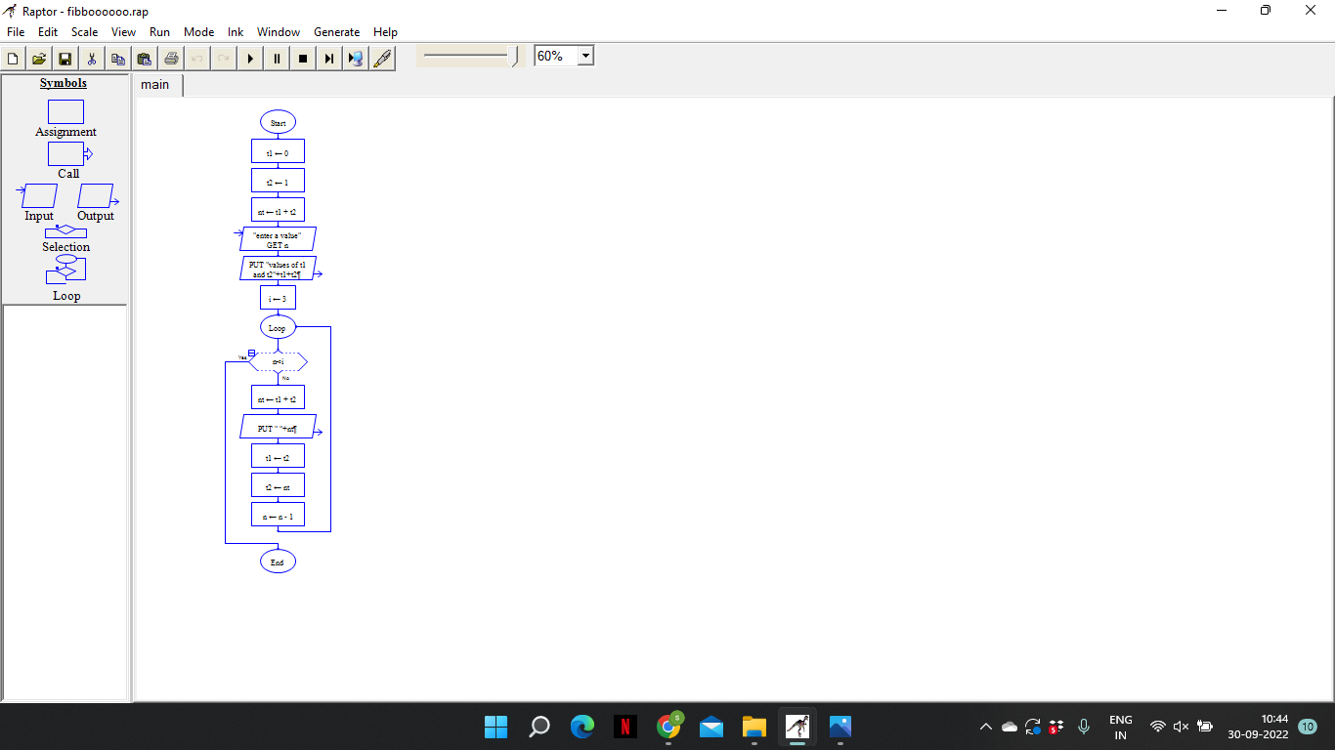

1. Using Raptor – Draw and validate the flowchart to swap two characters.

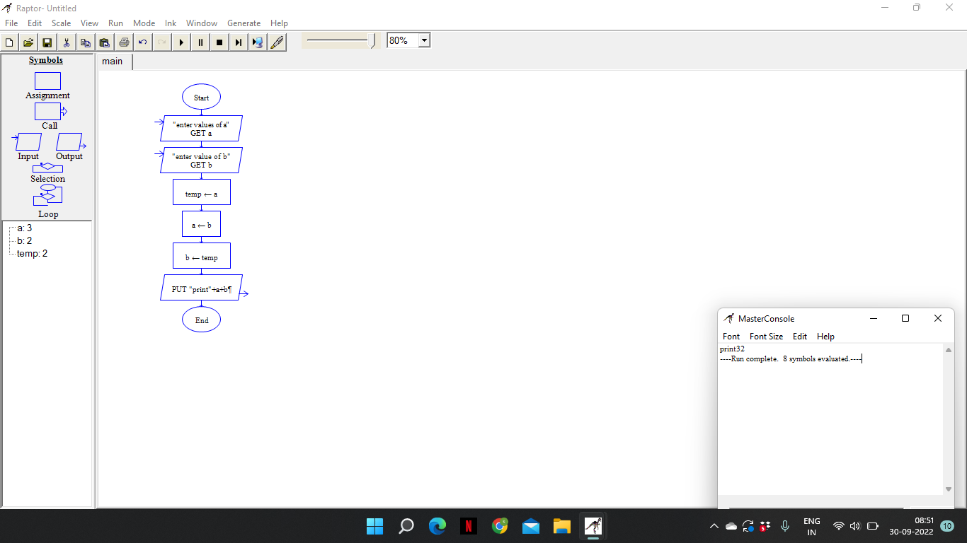

1. Using Raptor – Draw the flowchart to display the length of the string.

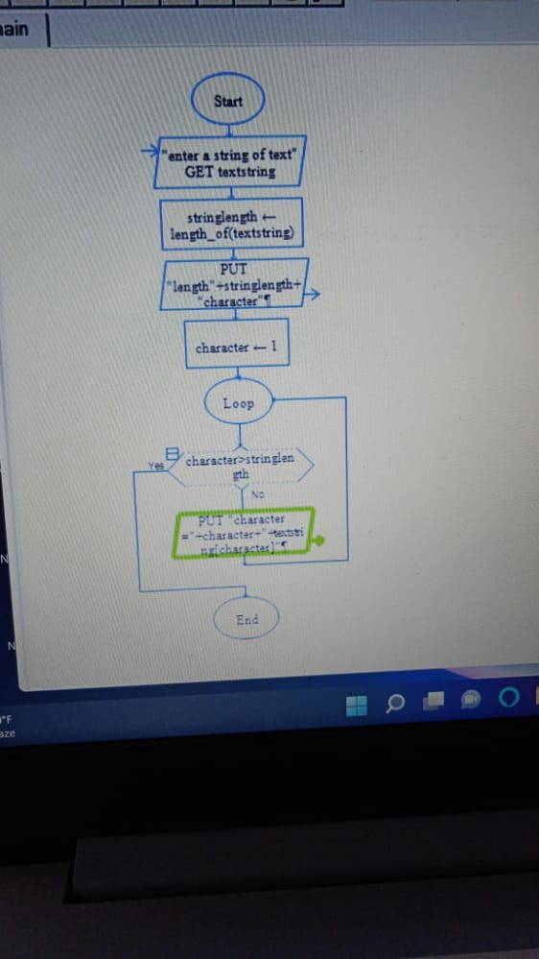

1. Using Raptor – Draw the flowchart to find whether the given number is prime or not.

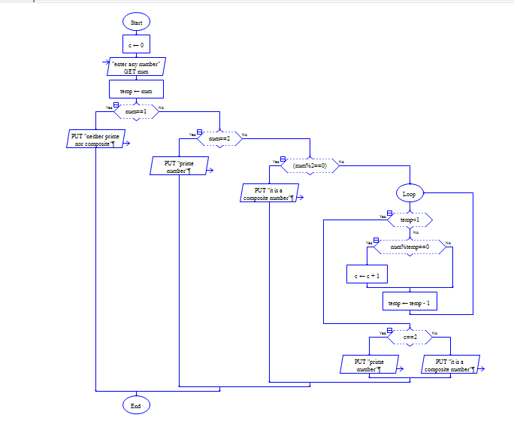

1. Find Cyclomatic Complexity for a graph having number of edges as 12, number of nodes as 13 and number of predicate nodes in the flow graph as 5.

